|  |  |
| --- | --- |
| **Installation de Eyes of Network** | |
| *Process to install Eyes of Network with preconfining requires* | |
|  | Logo | solution |
| Auteur : | Date de publication : |

|  |  |
| --- | --- |
| Objectif | Installation of Eyes of Network |
| Ressources | Installation image, installation machine |
| Outils | Official document |
| URL | https://www.eyesofnetwork.com/files/EyesOfNetwork-documentations-v5.zip |
| Autres | Another informations |

**Convention**

Par convention, les informations particulières seront mises en avant tout au long de cette procédure en respectant les règles et mise en page ci-dessous :

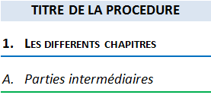

Ce paragraphe apporte à l‘utilisateur une information qui pourra l’aider ou lui rappeler un ou plusieurs points précis et utiles pour sa réalisation.

Ce paragraphe apporte à l’utilisateur une information importante sur un ou plusieurs points précis.  
Celle-ci est indispensable pour la bonne réalisation de la procédure.

Table des matières

installation EON 3

1. Pré-installation 3

2. Installation 4

# installation EON

## Pré-installation

Eyes of Network is a complete monitoring system combining several tools in a single system. It is present in the form of an operating system running with CentOS in CLI and configurable with a web interface.

Here is the first vision we can have when booting the installation image.

We are offered installation and possible testing beforehand.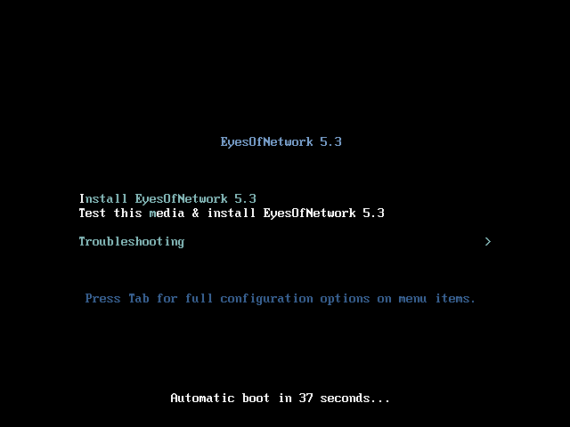

The language configuration is then displayed.

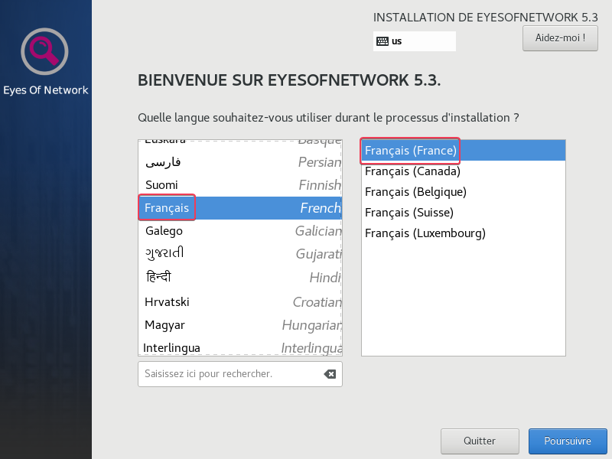

Then click on "Continue" after the selection.

Then several options are offered before the installation begins. First of all, the IP address of our network card must be changed in "host name and network".



Here we have to activate the interface in the top right corner and click on "configure", in the "IPv4 Parameter" section we change the "method" from "automatic (DHCP)" to "Manual". So we can add the address, mask and gateway statically and click on save.

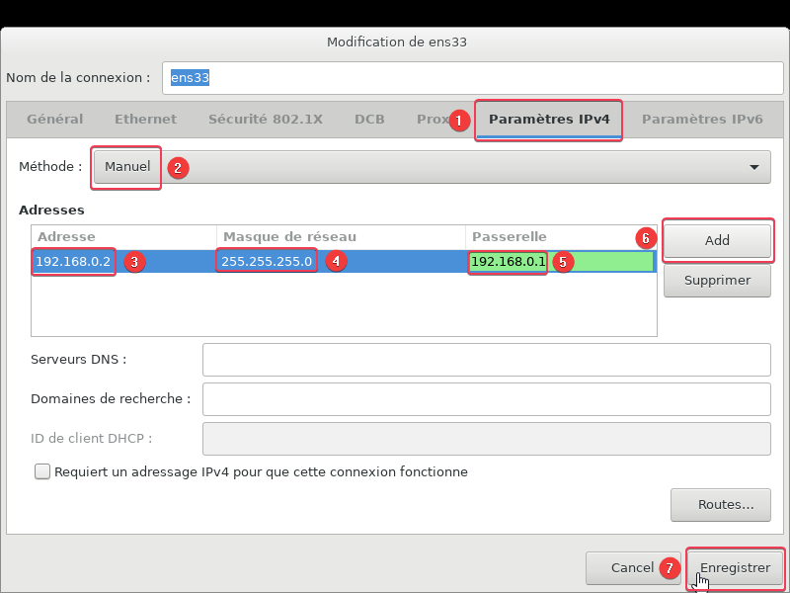 It is essential to put a server (whatever it is) on a fixed ip manually on the physical machine.

The system can then be installed.

## Installation

The installation is carried out after clicking on "install".

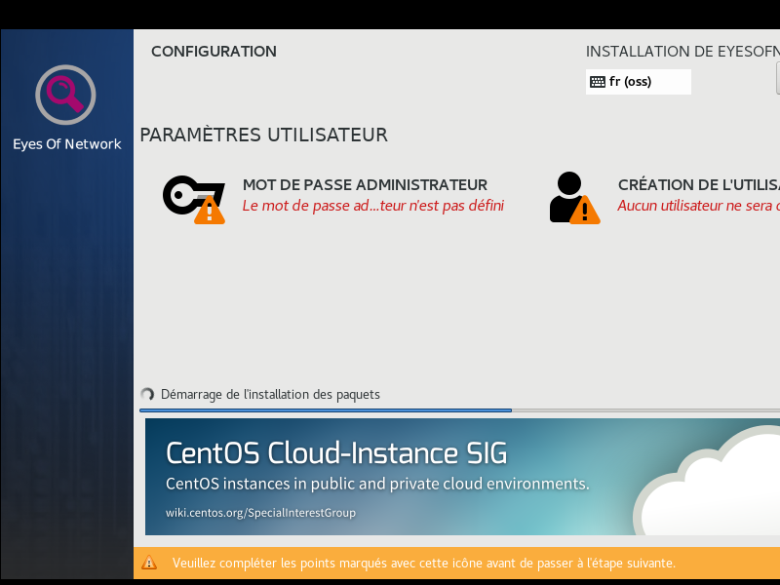 During the installation period you must create the password for the super user (root) account, here called "ADMINISTRATOR". It is necessary to put a strong password. 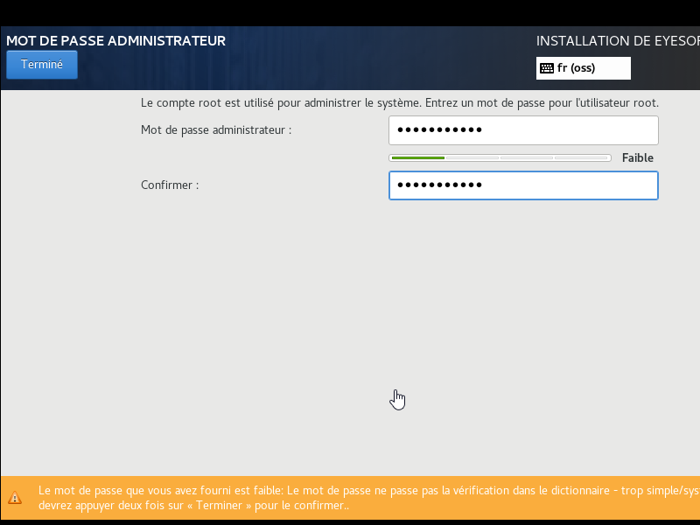

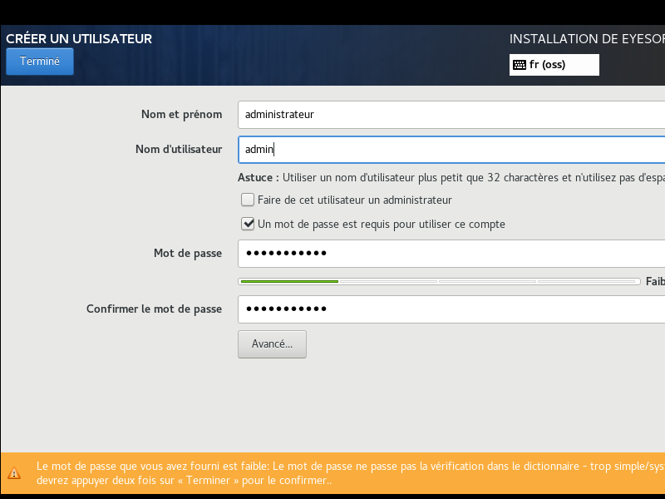It is also recommended to create another user for using an SSH connection. Here we create the administrator user different from root.

Once these two options have been made and the installation is complete the system requires a reboot. Here is the final interface.

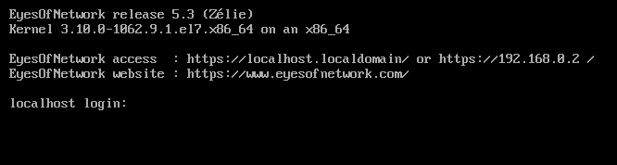

Most of the configuration is done on the web interface by accessing it through the IP address. The default username and password are "admin" and "admin" respectively.

It is important to change them afterwards. You should then get an interface like this one.